**Curriculum Vitae**

**PERSONAL DETAILS**

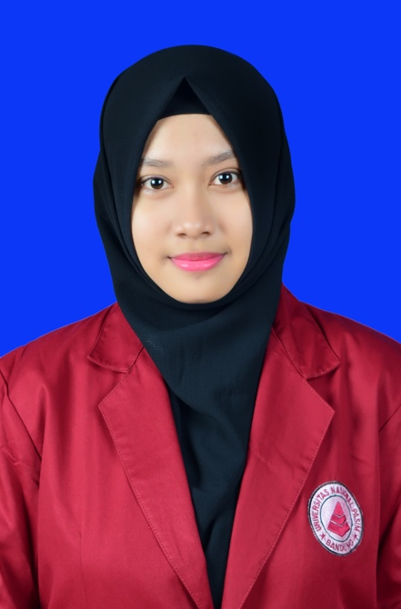

Full Name : Agustria Wantiningtyas

Place, Date of Birth : Banyumas, August 9, 1995

Sex : Female

Religion : Islam

Nationality : Indonesian

­­­­­­­Address : Alasmalang, Rt 03 Rw 04 Kemranjen,

Banyumas 53194 Jawa Tengah

Current Address : Kebon Kacang Street No.12

Tanah Abang, Jakarta Pusat

Maritial Status : Single

E-mail Address : agustriatyas@gmail.com

Handphone : 0857 - 2103 - 7115

**EDUCATION DETAILS**

**Formal Education**

Elementary : State Elementary School 1 Karangjati (2007)

Junior High School : State Junior High School 1 Sumpiuh (2010)

Senior High School : State Senior High School Banyumas (2013)

Major : Science

University : PASIM National University – Bandung (2013 - now)

Major : D3 Manajemen Informatika

**Non-Formal Education**

* Algorithm Course (2013 - 2015)
* Database Course (2014)
* HTML Course (2013)
* PHP Course (Native) (2014)
* PHP Course (CI Framework) (2014 - 2015)

**WORK EXPERIENCES**

1. Academic Apprentice Staff at PASIM National University (2013)
2. Kabag Academic Apprentice Staff at PASIM National University (2014)
3. LPPM and PPMB PUB Apprentice Staff at PASIM National University (2014-2015)
4. Software Engineer at PT Waditra Reka Cipta Bandung (September 2015 – April 2016)
5. Quality Engineer at PT Sepulsa Teknologi Indonesia (Mei 2016 - now)

**INTEREST**

* Quality Engineer
* Software Engineer
* Technical Writter
* Implementor

**SKILLS**

Developer : HTML, PHP Native, PHP Framework (CI), C,C++, Javasript, CSS, Object Oriented

Programming, CodeIgniter DataMapper

Database : MySQL, PhpMyAdmin, SQL Server

Design : Photoshop, Adobe Flash

Operating System : Windows

Office : Microsoft Office, Microsoft Excel

**PROJECT EXPERIENCES**

1. Laundry Information System in C Language
2. Train Reservation Information System in Vb.net and MySQL database
3. Sale Information System in PHP Native and MySQL database
4. Education Information System in PHP (CI Framework) and MySQL database
5. Static Website in HTML, CSS and Javascript
6. Education Aplication about Rodent in C++
7. Eyes Hospital Information System in PHP CodeIgniter and SQL Server database
8. Licensing Information System in PHP CodeIgniter and MySQL database
9. API Automated Test Using frisby.js for PT Sepulsa Technology Indonesia
10. Automation Test System for Mobile Web Using Nightwatch PT Sepulsa Technology Indonesia
11. Automation Test System for Web Using Nightwatch PT Sepulsa Technology Indonesia
12. Autmation Test System for iOS Using XCUI PT Sepulsa Technology Indonesia
13. Automation Test System for Mobile Web Using Serenity BDD PT Sepulsa Technology Indonesia

**ORGANIZATION EXPERIENCES**

* Member of KIR Junior High School 1 Sumpiuh (2007 - 2010)
* Treasurer of PMR Senior High School Banyumas (2010 - 2013)
* Member of HIMAMI Pasim National University (2013-2015).
* Secretary of PUB Pasim National University (2014 - 2015)
* Secretary of PPMB PUB Pasim National University (2014-2015)

**PERSONALITY**

* Responsible
* Good attitude
* Kind
* Communicative
* Tolerant
* Target Oriented
* Honest

|  |  |
| --- | --- |
|  | Jakarta, February 2017  **Agustria Wantiningtyas** |